Question 1:

The proof that J is constant following the motion is located in the appendix. Checks I have used to see how accurate my code for solving the restricted three-body problem were of using smaller time-steps and considering J’s value along the path. What I have done is told the code to stop running if the calculated value of J along the path varies from its original value by 10⁻³ (also, this can be altered during use – the reason why I have set this as the default is as this is a modest value and allows question 3 to be run for 15 secs). This is hence automatically checking every outputted trajectory, so this error check is utilized for all forthcoming exercises. I also tried using smaller initial time steps and comparing the trajectories and a sample of these can be seen in the appendix.

Question 2:

A proof that there exist analytic stable circular orbits about P₂ is in the appendix. This proof also shows that we can only have these orbits when the angular frequency (“k” in the appendix) takes on a specific value depending only on a. In fact, it can take on one of two values, as is the solution of a quadratic, both of which produce stable circular orbits. I have used the positive one arbitrarily, but a simple overwrite with ‘-’ where the ‘+’ is shows that in the code it also makes no difference in the visualisation of the orbit. Various orbits for differing a (a<<1) are in the appendix.

Question 3:

The trajectory plots are in the appendix.
I have estimated how much J has altered during the motion to give an indication of the accuracy of the numerical integrations. Since these variations only vary in order of the initial time step (10⁻⁴), I believe these are tolerable.
One thing to explain about these plots is that the region which can go off to infinity (i.e. in the first plot, outside the circle) is a very low potential area, along with the regions near P₁ and P₂, so less energetic particles cannot penetrate in or out of the P₁ and P₂ region to infinity – a potential barrier. The higher potentials are in the place between these, and this shrinks as we give the particle more initial energy (by increasing kinetic energy by increasing initial speed), enabling it more freedom of motion.
As can be seen from all of the plots, (especially those for which v₀ є {-1.19,-1.3,-1.4}), the allowed regions are a very good guide to the size of the trajectory, as the motions are always contained in these regions, and also the behaviour at the boundary of something that is a potential barrier is emphasized very well (looking at v₀ = -1.3)! Close to the boundary (v₀ є {-1.3,-1.4,-1.7} show this), we have the expected result at a potential barrier, no flow through. Noting that, the motion is still smooth on the edges, which is physical.
I believe that v₀ = -1.3 is the most suitable for transport from P₂ to P₁, as: firstly we need -1.3 ≥ v₀, otherwise an increase in energy would be required during flight to escape through the potential barrier. For -1.6 ≥ v₀, the motion is so erratic we don’t even approach P₁. Okay, now my reason for choosing -1.3 over -1.4 was as although it appears in the -1.4 case it takes fewer rotations about P₂ (so perceivably less time) before you get to move to P₁, that doesn’t negate the safety issue. Suppose there was some deflection of motion to the spacecraft (some sort of collision) increasing its speed to the negative x direction – then we can see that there is no potential barrier to the rest of space, so it’s feasible that the ship may just move out into space, away from P₁ & P₂. Also, both of these trajectories only require initial energy input. So, less fuel would have to be used to get up to -1.3 rather than -1.4. (However, in this model, with only empty space, P₁, P₂ and my spacecraft – the -1.4 case is perfectly safe and seems faster. The choice depends on how much fuel costs at P₂).

Question 4:

Firstly, I’d like to point out that trivially, from the governing equations, we get equilibrium => grad Ω = 0 => equilibria are extrema of Ω. In the specific code for this question, I have developed a routine to locate all equilibria of this system, basically by noting that the equilibrium points on the x – axis form saddles of Ω. As along an axis parallel to the y – axis, these must be minima, as by looking at the contour plots and symmetry about the x – axis negating saddles, if otherwise then you’d automatically get the Ω surface to slope down to -∞, but this is not true as seen in the contour plot. However along the x-axis, these points are maxima, as they must stay for any μ, since we must have the -∞ values singularities at P₁ & P₂ and Ω → -∞ as |x| → ∞. So, here I have used this to allow myself to use a subroutine that locates minima of a function (‘MinCL’) to get the positions of all the equilibria. Contour plots are in the appendix.
Looking at the contour plots, I definitely think that the L₁, L₂ & L₃ points are unstable, as even a perturbation of order 10⁻⁶ at these points causes the particle to fly off into lower potential space, independent of the value of µ seemingly (see trajectory plots in the appendix).
Using a linear perturbation analysis about these Lagrange points, we see that this is confirmed as the equilibria are saddles. This arises from the contour plots as they imply these points are also saddles in the sense of Ω extrema.

Question 5:

As μ is decrease, I believe L₄ and L₅ become more stable. Before I digress, let me say that as the situation is symmetric in the x – axis (due to the structure of ∂Ω/∂y) that I can work with L₄ and produce equal results for L₅.This is visible with μ = ½ having the least stability, though not of the degree seen at the x – axis Lagrange points. Moving to μ = 0.025, the instability is only of order 10 times the perturbation, that is to say, in this time period, you only move that far away (found by looking at the second plot for this μ value). In the smallest μ case used, the motion is so small, I would put this down to error in RK4f rather than an unstable equilibria, since this is seems much more likely. Hence I would argue that for μ in a largish ball about ½ (saying that the μ = μ’ case is the μ = 1 - μ’ case reflected in the y – axis), but as μ approaches zero (equivalently, μ → 1), then L₄ becomes stable. Hence, I must find the μ_{c} dividing stability there and instability.
By performing a perturbation analysis about L₄, I found that μ_{c} = 0.039 to 2 significant figures. When μ_{c} ≥ μ , we have stability at L₄, and the type of stable equilibrium point is a centre. Motion about L₄ is an elliptical orbit, with geometric properties (i.e. length of major axes) determined by initial conditions.

Question 6:

For the Sun-Jupiter system, μ = 0.000954 < μ_{c}.

The existence of the Trojans at the L₄/L₅ point is thus compatible with my findings.

For the Earth-Moon system, μ = 0.012141 < μ_{c}.

So, if the space we were looking at just contained the Earth and Moon, there would exist L₄ or L₅ points. However, I believe that there is no analogue here to the previous case for a couple of reasons:

- Firstly, our solar system has more than just the Earth and Moon, so other massive bodies would affect stability at the equilateral points, for example, the Sun, which obviously has an effect on the Earth (our heliocentric system), so would indubitably challenge any stability at L₄/L₅.

- In this model, we take the mass of the third body is negligible compared to the other two bodies. Using the Sun-Jupiter system’s definition of how negligible this needs to be, the maximal number of asteroids we could have at the Earth-Moon system’s L₄ is four!! This, coupled with i) implies why I’d imagine only debris clouds could be present at L₄ or L₅.

Appendix:

Question 1:

What I’ve done to compare accuracies is to develop a program that finds the trajectory given the governing equations, and solves it using the RKf4 subroutine using three different levels of error checking (i.e. allowing for different values of maximal absolute error, relative error and initial time step). Then, the path is displayed for the three specifications, so I can compare the levels of error checking in each. This helps to locate the values which form a balance between efficiency and number of calculations against accuracy. I have provided such a trajectory plot to show the general idea as to why I am using absolute & relative errors of 10⁻⁴ and an initial time step of around 10⁻⁴ too. I am basing this judgement on further comparisons for smaller error levels (around 10⁻⁷) and how we see real curves, like in my error levels, physically in our galaxy.

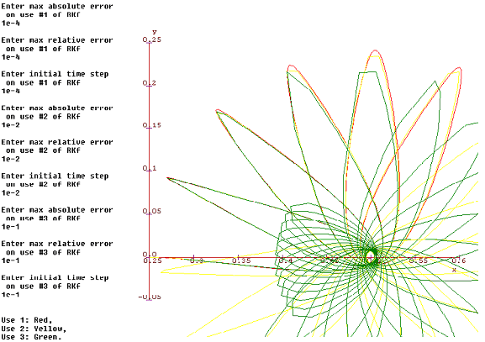

Question 2:

a=0.1:

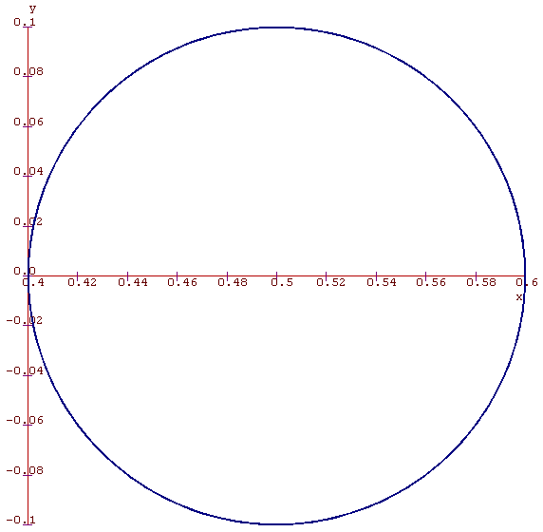

a=0.01:

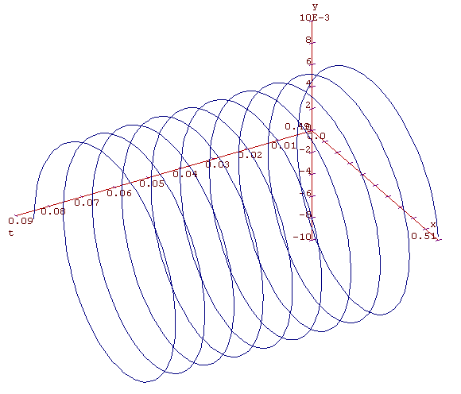

Question 3:

v₀=-1.1:
J varies by around 5x10⁻⁵.
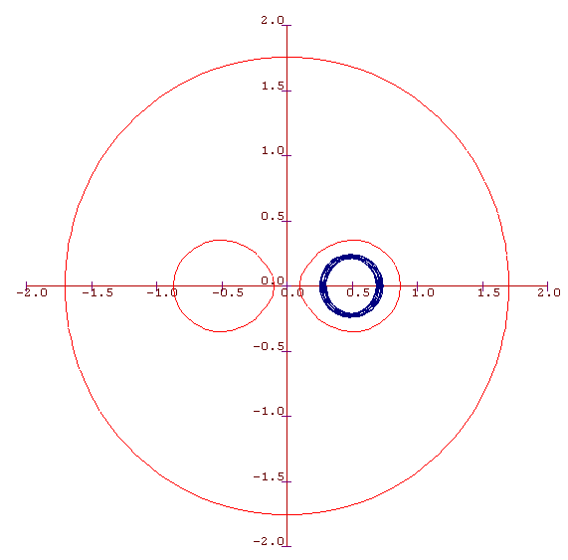
v₀ = -1.19:
J varies by around 3.5x10⁻⁴.
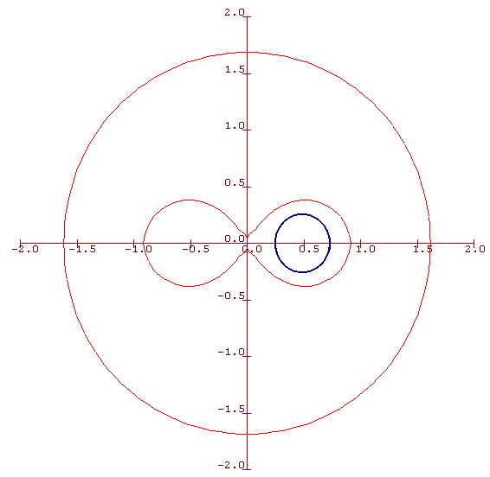
v₀ = -1.3:
J varies by around 1.8x10⁻⁴.
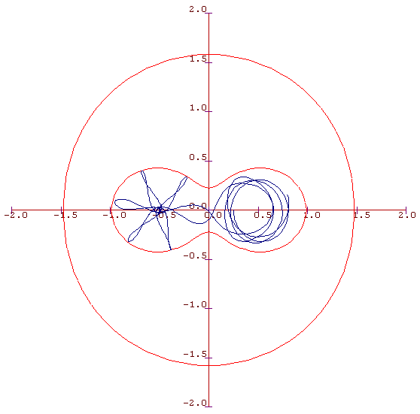
v₀ = -1.4:
J varies by around 1.4x10⁻⁴.
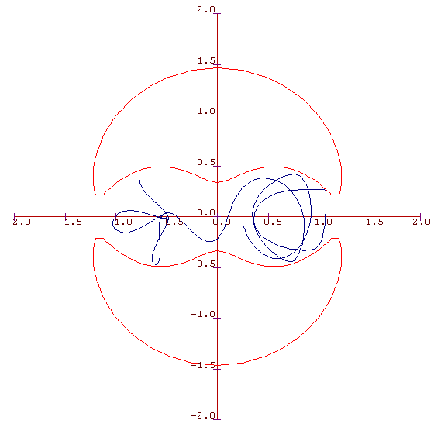
v₀ = -1.6:
J varies by around 2.7x10⁻⁴.

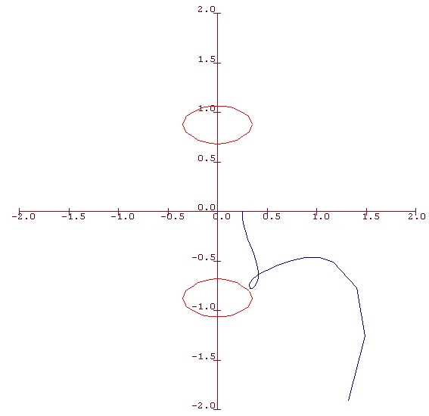
v₀ =-1.7:
J varies by around 1.4x10⁻⁴.
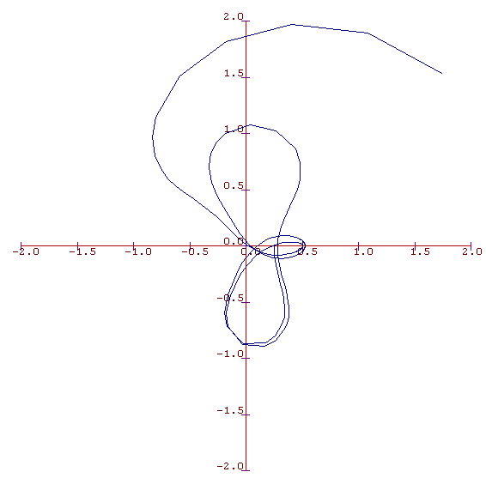

Question 4:

µ = 0.5:

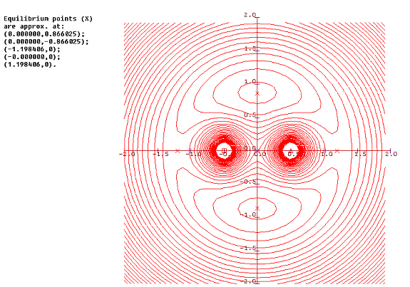

μ = 0.25:
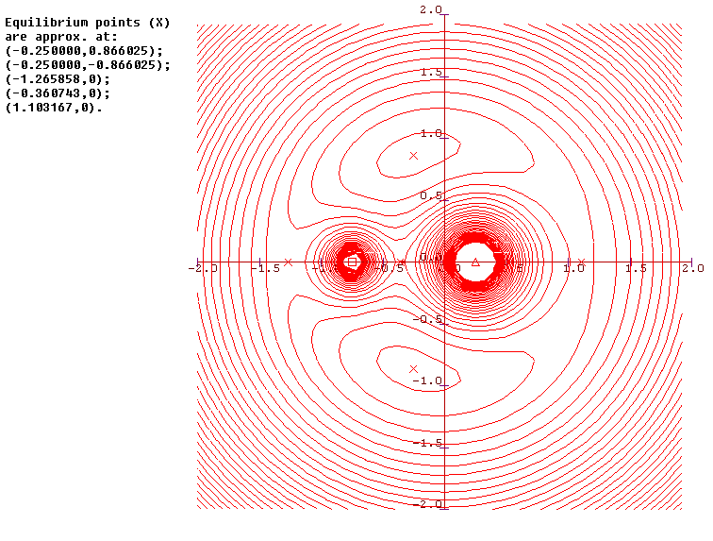
μ = 0.1:
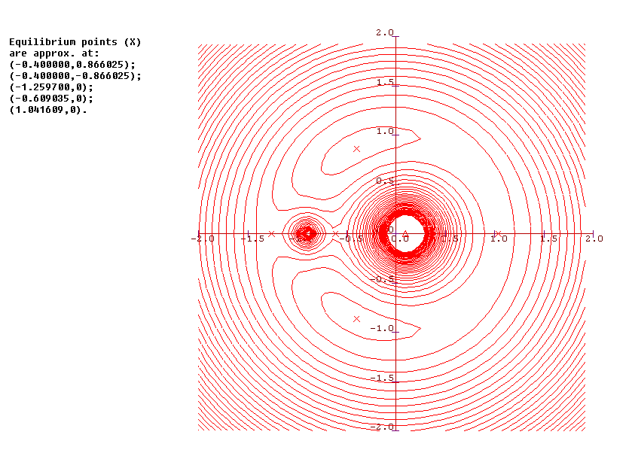

Question 5:

μ= ½, perturbation of L₁ by 10⁻⁹. Heavily unstable.

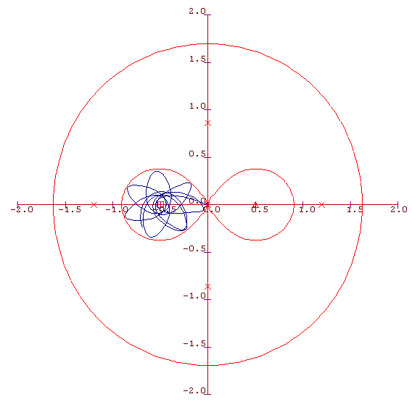
μ = ¼, perturbation of L₂ by 10⁻⁶. Heavily unstable.

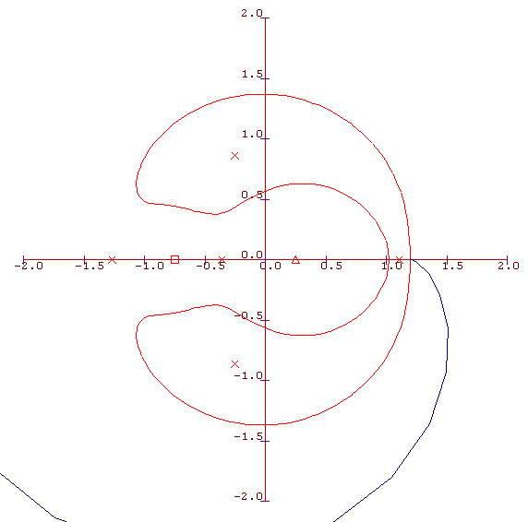

μ = 0.001, perturbation of L₃ by 10⁻⁶. Again, heavily unstable.

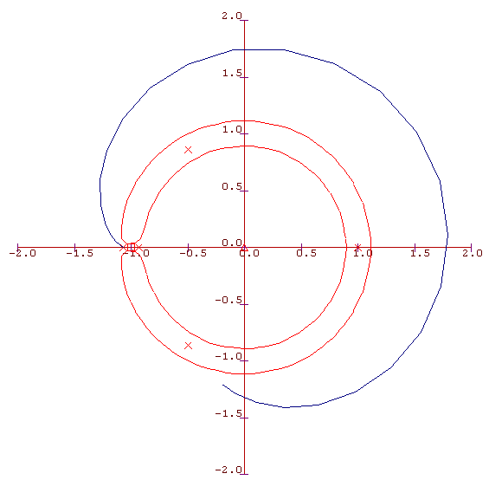

Question 5:

μ = 0.5, perturbation of L₃ by 10⁻⁴.

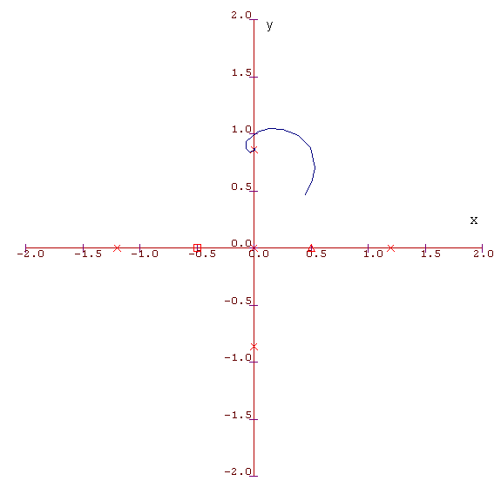
μ = 0.1, perturbation of L₃ by 10⁻⁴.

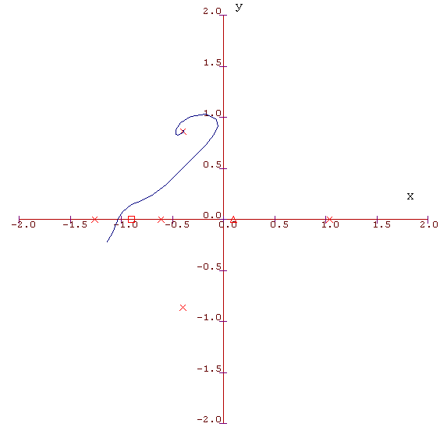
μ = 0.05, perturbation of L₃ by 10⁻⁴.

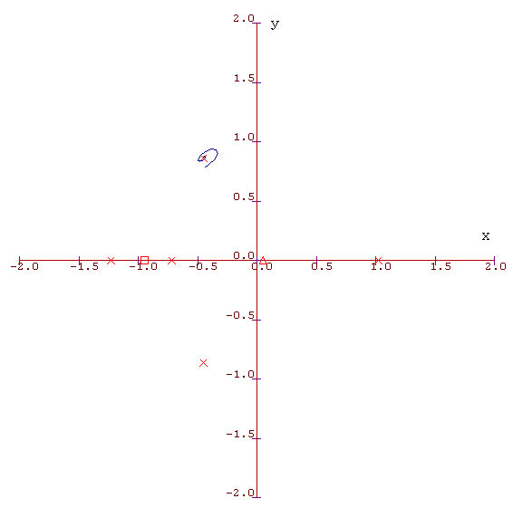
μ = 0.025, perturbation of L₃ by 10⁻⁴.

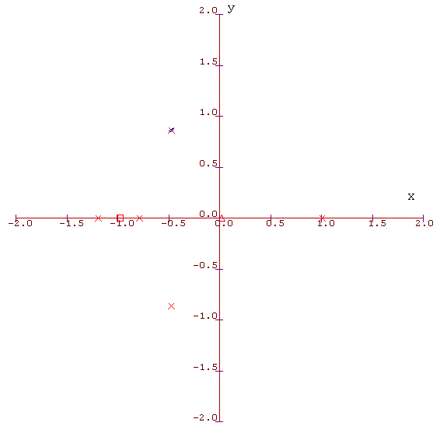

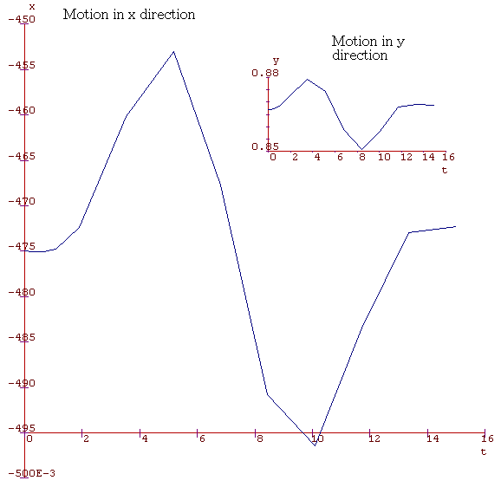
μ = 0.01, perturbation of L₃ by 10⁻⁴.

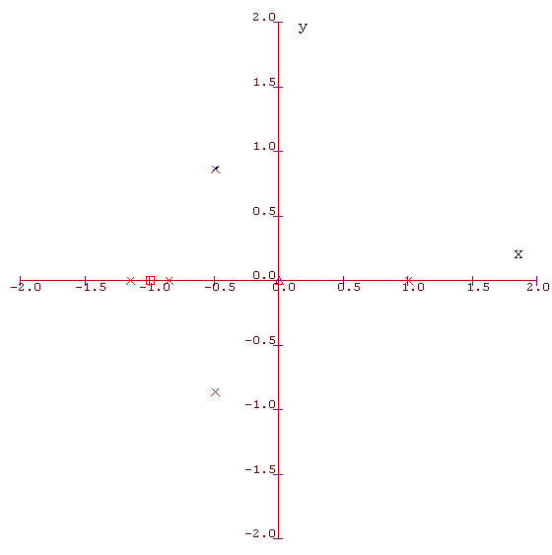

Program Listing:

2_3General3Error.c – Runs RKf4 with different levels of error checking. Also shows off the use of the constancy of J. Prints plots of trajectories given the governing equations too.
2_3General3.c – Runs RKf4 with ‘constant J’ check, under chosen error levels. Also prints J evaluated over an even interval of time (split into ten) to give a general idea of accuracy.
2_3OmCon.c – Displays contours *and* the surface of Ω (to be used later on) for varying μ.
2_3SurfingaboutP2.c – Finds the correct initial conditions for small orbits about P2 and displays them.
2_3General3OmConHalfMu.c – Runs the three body problem with μ = ½. Plots potential barrier and trajectory.
2_3FindingallEquilibria.c – Locates the x – axis equilibria via use of ‘MinCL’, and provides plots of Ω about these points in order to determine what type of extrema they are.
2_3General3OmConLPts.c – Locates and plots all equilibria, displays trajectory and potential barrier.

2_3General3Error.c

#include <catam.h>
double mu;
double tiny;

double d1(double x, double y)
{
return pow((x+1-mu)*(x+1-mu)+y*y,0.5);
}
double d2(double x, double y)
{
return pow((x-mu)*(x-mu)+y*y,0.5);
}
void F(double t, double *x, double *xdot)
{
xdot[0]=x[2];
xdot[1]=x[3];
xdot[2]=2*x[3]+x[0]-mu*(x[0]+1-mu)/pow(d1(x[0],x[1]),3)-(1-mu)*(x[0]-mu)/pow(d2(x[0],x[1]),3);
xdot[3]=-2*x[2]+x[1]-mu*x[1]/pow(d1(x[0],x[1]),3)-(1-mu)*x[1]/pow(d2(x[0],x[1]),3);
}

double Om(double x, double y)
{
return -0.5*mu*d1(x,y)*d1(x,y)-0.5*(1-mu)*d2(x,y)*d2(x,y)-mu/d1(x,y)-(1-mu)/d2(x,y);
}

double J(double x, double y, double u, double v)
{
return 0.5*u*u+0.5*v*v+Om(x,y);
}

int MainCL(void)

{
double aberr=1e-4;
double relerr=1e-4;
double dtmin=1e-9;
double x[4];
double ji;
double X,Y,U,V;
double xdot[4];
double t;
double tfinal;
double xdata[1000];
double ydata[1000];
double tdata[1000];
double Jdata[1000];
int nres;
int i;
int use;
double dt;
int nleft;

use=0;
mu=ReadDoubleCL("Enter mu:",0.5);
tiny=ReadDoubleCL("Enter maximal variance of J allowed",1e-3);
X=ReadDoubleCL("Enter initial x-coordinate:",0.25);
Y=ReadDoubleCL("Enter initial y-coordinate:",0);
U=ReadDoubleCL("Enter initial velocity in the x-direction:",0);
V=ReadDoubleCL("Enter initial velocity in the y-direction:",0);
tfinal=ReadDoubleCL("Enter time you want to integrate up to:",15);

printf("Note: Standard RKf4 use has absolute\nerror 1e-4, relative error at 1e-4\nand initial time step at (of\norder) 1e-4.\n");

while (use<3) {

for (i=0;i<4;i++) {xdot[i]=0;}
x[0]=X;x[1]=Y;x[2]=U;x[3]=V;
for (i=0;i<1000;i++) {
xdata[i]=0;
ydata[i]=0;
tdata[i]=0;
Jdata[i]=0;
}

t=0;
printf("\nEnter max absolute error\n on use #%i of RKf\n",use+1);
fflush(stdout);
scanf("%lf",&aberr);
printf("\nEnter max relative error\n on use #%i of RKf\n",use+1);
fflush(stdout);
scanf("%lf",&relerr);
printf("\nEnter initial time step\n on use #%i of RKf\n",use+1);
fflush(stdout);
scanf("%lf",&dt);

nleft=(int)(tfinal/dt);
dt=tfinal/nleft;
nres=0;

ji=J(x[0],x[1],x[2],x[3]);
while (nleft>0) {
if (!RkfCL(4,aberr,relerr,&t,&dt,dtmin,F,x,xdot,&nleft)) {
printf("\n\nEnding on Use %i: Criteria for accurate\n RKf use falls outside\n of tolerances :(\n",use+1);
HaltCL();
}
if (nres<1000) {
xdata[nres]=x[0];
ydata[nres]=x[1];
tdata[nres]=t;
Jdata[nres]=J(x[0],x[1],x[2],x[3]);
nres++;
if (fabs(Jdata[nres]-ji)<tiny) {printf("Ending on Use %i:\n J varies unnacceptably.\n",use+1);
HaltCL();
}
}
}
PauseCL();
XAxisLabelCL("x");
YAxisLabelCL("y");
if (use==0) {XYCurveCL(xdata,ydata,nres,1,JOIN,RedCC,AUTOAXES);
}
if (use==1) {XYCurveCL(xdata,ydata,nres,1,JOIN,YellowCC,PRESET);
}
if (use==2) {XYCurveCL(xdata,ydata,nres,1,JOIN,GreenCC,PRESET);
}

use++;
}

printf("\n\nUse 1: Red,\nUse 2: Yellow,\nUse 3: Green.");

return 0;}

2_3General3.c

#include <catam.h>
double mu;
double tiny;

double d1(double x, double y)
{
return pow((x+1-mu)*(x+1-mu)+y*y,0.5);
}
double d2(double x, double y)
{
return pow((x-mu)*(x-mu)+y*y,0.5);
}
void F(double t, double *x, double *xdot)
{
xdot[0]=x[2];
xdot[1]=x[3];
xdot[2]=2*x[3]+x[0]-mu*(x[0]+1-mu)/pow(d1(x[0],x[1]),3)-(1-mu)*(x[0]-mu)/pow(d2(x[0],x[1]),3);
xdot[3]=-2*x[2]+x[1]-mu*x[1]/pow(d1(x[0],x[1]),3)-(1-mu)*x[1]/pow(d2(x[0],x[1]),3);
}

double Om(double x, double y)
{
return -0.5*mu*d1(x,y)*d1(x,y)-0.5*(1-mu)*d2(x,y)*d2(x,y)-mu/d1(x,y)-(1-mu)/d2(x,y);
}

double J(double x, double y, double u, double v)
{
return 0.5*u*u+0.5*v*v+Om(x,y);
}

int MainCL(void)

{
double aberr=1e-4;
double relerr=1e-4;
double dtmin=1e-9;
double x[4];
double ji;
double xdot[4];
double t;
double tfinal;
double xdata[1000];
double ydata[1000];
double tdata[1000];
double Jdata[1000];
int nres;
int i;
double dt;
int nleft;

t=0;
mu=ReadDoubleCL("Enter mu:",0.5);
tiny=ReadDoubleCL("Enter maximal variance of J allowed",1e-3);
x[0]=ReadDoubleCL("Enter initial x-coordinate:",0.25);
x[1]=ReadDoubleCL("Enter initial y-coordinate:",0);
x[2]=ReadDoubleCL("Enter initial velocity in the x-direction:",0);
x[3]=ReadDoubleCL("Enter initial velocity in the y-direction:",0);
tfinal=ReadDoubleCL("Enter time you want to integrate up to:",15);
dt=1e-4;
nleft=(int)(tfinal/dt);
dt=tfinal/nleft;
nres=0;

ji=J(x[0],x[1],x[2],x[3]);
while (nleft>0) {
if (!RkfCL(4,aberr,relerr,&t,&dt,dtmin,F,x,xdot,&nleft)) {
printf("End: Criteria for accurate RKf use\nfalls outside of tolerances :(");
HaltCL();
}
if (nres<1000) {
xdata[nres]=x[0];
ydata[nres]=x[1];
tdata[nres]=t;
Jdata[nres]=J(x[0],x[1],x[2],x[3]);
nres++;
if (fabs(Jdata[nres]-ji)<tiny) {printf("End: J varies unnacceptably");HaltCL();}
}
}
PauseCL();
XAxisLabelCL("x");
YAxisLabelCL("y");
/* XYZCurveCL(tdata,xdata,ydata,nres,1,JOIN,RedCC,AUTOAXES);*/
XYCurveCL(xdata,ydata,nres,1,JOIN,BlueCC,AUTOAXES);

printf("Variation of J along path:\n\n");
printf("Time: J:\n");
for (i=0;i<10;i++) {printf("%lf %lf\n",tdata[100*i],Jdata[100*i]);}
printf("\nValue of J initially: %lf\n",ji);
return 0;}

2_3OmCon.c

#include <catam.h>
double mu;

double d1(double x, double y)
{
return pow((x+1-mu)*(x+1-mu)+y*y,0.5);
}
double d2(double x, double y)
{
return pow((x-mu)*(x-mu)+y*y,0.5);
}
double Om(double x, double y)
{
return -0.5*mu*d1(x,y)*d1(x,y)-0.5*(1-mu)*d2(x,y)*d2(x,y)-mu/d1(x,y)-(1-mu)/d2(x,y);
}

int MainCL(void) {
double x[50];
double y[50];
double z[50][50];
int i;
int j;
mu=0.5;
while (mu<2) {
mu=ReadDoubleCL("Enter mu:",0.5);

for (i=0;i<50;i++) {
x[i]=-2+(double)i/12.5;
y[i]=-2+(double)i/12.5;
}
for (i=0;i<50;i++) {
for (j=0;j<50;j++) {
z[i][j]=Om(x[i],y[j]);
}
}

j=0;
j=ReadIntCL("'1' for a surface, '2' for a contour plot",1);

if(j==2) {
XYZContourCL(x,y,z,50,50,1,50,50,-5,0,CONTOURS2D,RedCC,AUTOAXES);
}
if(j==1) {
XYZSurfaceCL(x,y,z,50,50,1,50,WIREFRAME,RedCC,WhiteCC,AUTOAXES);
}

XYSymbolCL(mu,0,TRIANGLE);
XYSymbolCL(mu-1,0,SQUARE);
XYSymbolCL(mu-0.5,0.866025,XCROSS);
XYSymbolCL(mu-0.5,-0.866025,XCROSS);
PauseCL();
WClearCL();
}

return 0;
}

2_3SurfingaboutP2.c

#include <catam.h>

double d2(double x,double y)
{
return pow(y*y+(x-0.5)*(x-0.5),0.5);
}

double J(double x,double y,double u, double v)
{
return 0.5*u*u+0.5*v*v-0.5/d2(x,y);
}

void F(double t, double *x, double *xdot)
{
xdot[0]=x[2];
xdot[1]=x[3];
xdot[2]=2*x[3]-0.5*(x[0]-0.5)/pow(d2(x[0],x[1]),3);
xdot[3]=-2*x[2]-0.5*x[1]/pow(d2(x[0],x[1]),3);
}

int MainCL(void) {

double aberr=1e-4;
double relerr=1e-4;
double dtmin=1e-9;
double x[4];
double xdot[4];
double t;
double a;
double tfinal;
double xdata[1000];
double ydata[1000];
double udata[1000];
double vdata[1000];
double tdata[1000];
int nres;
int i;
double dt;
int nleft;

t=0;
a=ReadDoubleCL("Enter radius of ideal orbit:",0.1);
x[0]=0.5+a;
x[1]=0;
x[2]=0;
x[3]=a*(-1+sqrt(1+1/(2*pow(a,3))));
tfinal=ReadDoubleCL("Enter time you want to integrate up to:",15);
dt=1e-4;
nleft=(int) (tfinal/dt);
nres=0;
while (nleft>0) {
if(!RkfCL(4,aberr,relerr,&t,&dt,dtmin,F,x,xdot,&nleft)) {
printf("Falls outside of tolerances :(");
HaltCL();
}
if (nres<1000) {
xdata[nres]=x[0];
ydata[nres]=x[1];
udata[nres]=x[2];
vdata[nres]=x[3];
tdata[nres]=t;
nres++;
}
}
PauseCL();
printf("Enter 1 for a 2D representation\nor 2 for a 3D one.\n");
fflush(stdout);
scanf("%i",&i);
if (i==1) {
XAxisLabelCL("x");
YAxisLabelCL("y");
XYCurveCL(xdata,ydata,nres,1,JOIN,BlueCC,AUTOAXES);
}
if (i==2) {
XYZCurveCL(tdata,xdata,ydata,nres,1,JOIN,BlueCC,AUTOAXES);
XAxisLabelCL("t");
YAxisLabelCL("x");
ZAxisLabelCL("y");
}
printf("\n\nSample data of distance for\nP2 and J during the motion:\n\n");
printf("Time: P2 dist.: J:\n");
for (i=0;i<10;i++) {printf("%lf %lf %lf\n",tdata[100*i],d2(xdata[100*i],ydata[100*i]),J(xdata[100*i],ydata[100*i],udata[100*i],vdata[100*i]));}
printf("\n\n\n\n");
PauseCL();
return 0;}

2_3General3OmConHalfMu.c

#include <catam.h>
/*Specifically for the equal mass case only!*/
double mu=0.5;
double ji;

double d1(double x, double y)
{
return pow((x+1-mu)*(x+1-mu)+y*y,0.5);
}
double d2(double x, double y)
{
return pow((x-mu)*(x-mu)+y*y,0.5);
}
void F(double t, double *x, double *xdot)
{
xdot[0]=x[2];
xdot[1]=x[3];
xdot[2]=2*x[3]+x[0]-mu*(x[0]+1-mu)/pow(d1(x[0],x[1]),3)-(1-mu)*(x[0]-mu)/pow(d2(x[0],x[1]),3);
xdot[3]=-2*x[2]+x[1]-mu*x[1]/pow(d1(x[0],x[1]),3)-(1-mu)*x[1]/pow(d2(x[0],x[1]),3);
}

double Om(double x, double y, double ji)
{
return -0.5*mu*d1(x,y)*d1(x,y)-0.5*(1-mu)*d2(x,y)*d2(x,y)-mu/d1(x,y)-(1-mu)/d2(x,y)-ji;
}

double J(double x, double y, double u, double v)
{
return 0.5*u*u+0.5*v*v+Om(x,y,0);
}

int MainCL(void)

{
double X[50],Y[50],Z[50][50];
double aberr=1e-4;
double relerr=1e-4;
double dtmin=1e-9;
double x[4];
double xdot[4];
double a,t;
double tfinal;
double xdata[1000];
double ydata[1000];
double tdata[1000];
double Jdata[1000];
int nres;
int i,j;
double dt;
int nleft;

t=0;
x[0]=ReadDoubleCL("Enter initial x-coordinate:",0.25);
x[1]=ReadDoubleCL("Enter initial y-coordinate:",0);
x[2]=ReadDoubleCL("Enter initial velocity in the x-direction:",0);
x[3]=ReadDoubleCL("Enter initial velocity in the y-direction:",-1.3);
tfinal=ReadDoubleCL("Enter time you want to integrate up to:",15);
dt=1e-4;
nleft=(int)(tfinal/dt);
dt=tfinal/nleft;
nres=0;

a=J(x[0],x[1],x[2],x[3]);

while (nleft>0) {
if (!RkfCL(4,aberr,relerr,&t,&dt,dtmin,F,x,xdot,&nleft)) {
printf("Falls outside of tolerances :(");
HaltCL();
}
if (nres<1000) {
xdata[nres]=x[0];
ydata[nres]=x[1];
tdata[nres]=t;
Jdata[nres]=J(x[0],x[1],x[2],x[3]);
nres++;
}
}

ji=a;
for (i=0;i<50;i++) {
X[i]=-2+(double)i/12.5;
Y[i]=-2+(double)i/12.5;
}
for (i=0;i<50;i++) {
for (j=0;j<50;j++) {
Z[i][j]=Om(X[i],Y[j],ji);
}
}

XYZContourCL(X,Y,Z,50,50,1,50,1,-0.0001,0,CONTOURS2D,RedCC,AUTOAXES);

PauseCL();
XAxisLabelCL("x");
YAxisLabelCL("y");
XYCurveCL(xdata,ydata,nres,1,JOIN,BlueCC,PRESET);
printf("Sample data of J during the motion:\n\n");
printf("Time: J:\n");
for (i=0;i<10;i++) {printf("%lf %lf\n",tdata[100*i],Jdata[100*i]);}
printf("\n\nJ = %lf initially\n",ji);
return 0;}

2_3FindingallEquilibria.c

#include <catam.h>
double mu;
double a,b,c,d;
double eql,eqm,eqr;
double x[10000],y[10000];
int i,I;

double d1(double x, double y)
{
return pow((x+1-mu)*(x+1-mu)+y*y,0.5);
}
double d2(double x, double y)
{
return pow((x-mu)*(x-mu)+y*y,0.5);
}

double MinusOmx(double x)
{
return -1*(-0.5*mu*pow(x+1-mu,2)-0.5*(1-mu)*pow(x-mu,2)-mu/fabs(x+1-mu)-(1-mu)/fabs(x-mu));
}

double Omx(double x)
{
return (-0.5*mu*pow(x+1-mu,2)-0.5*(1-mu)*pow(x-mu,2)-mu/fabs(x+1-mu)-(1-mu)/fabs(x-mu));
}

double Omay(double y, double a)
{
return -0.5*mu*d1(a,y)*d1(a,y)-0.5*(1-mu)*d2(a,y)*d2(a,y)-mu/d1(a,y)-(1-mu)/d2(a,y);
}

double Omeqtri(double x)
{
return -0.5*mu*d1(x,0.8660254)*d1(x,0.8660254)-0.5*(1-mu)*d2(x,0.8660254)*d2(x,0.8660254)-mu/d1(x,0.8660254)-(1-mu)/d2(x,0.8660254);
}

int MainCL(void) {
double u[500],v[500];
int i;

mu=ReadDoubleCL("Enter mu:",0.5);

CurveCL(Omx,-2,2,100,RedCC,AUTOAXES);

for (i=0;i<10000;i++) {
x[i]=-2+(double)i/2500;
y[i]=MinusOmx(x[i]);
}

a=1,b=2;

eql=MinCL(MinusOmx,-5,mu-1,1e-6);
eqm=MinCL(MinusOmx,mu-1,mu,1e-6);
eqr=MinCL(MinusOmx,mu,5,1e-6);

printf("eql = %lf\neqm = %lf\neqr = %lf",eql,eqm,eqr);
PauseCL();
WClearCL();
a=ReadDoubleCL("\n\nEnter equilibrium point",mu-0.5);

for(i=0;i<50;i++) {
u[i]=-2+(double)(i/12.5);
v[i]=Omay(u[i],a);
}

printf("\n\nEquilibrium point in y direction");
XYCurveCL(u,v,50,1,JOIN,RedCC,AUTOAXES);

PauseCL();
WClearCL();
printf("\n\nEquilateral equilibrium \npoint in x direction");
CurveCL(Omeqtri,-2,2,100,BlueCC,AUTOAXES);

return 0;
}

2_3General3OmConLPts.c

#include <catam.h>
double mu;
double tiny;
double ji;
double eql,eqm,eqr;
int k,I;
WindowCT w1,w2;

double d1(double x, double y)
{
return pow((x+1-mu)*(x+1-mu)+y*y,0.5);
}
double d2(double x, double y)
{
return pow((x-mu)*(x-mu)+y*y,0.5);
}
void F(double t, double *x, double *xdot)
{
xdot[0]=x[2];
xdot[1]=x[3];
xdot[2]=2*x[3]+x[0]-mu*(x[0]+1-mu)/pow(d1(x[0],x[1]),3)-(1-mu)*(x[0]-mu)/pow(d2(x[0],x[1]),3);
xdot[3]=-2*x[2]+x[1]-mu*x[1]/pow(d1(x[0],x[1]),3)-(1-mu)*x[1]/pow(d2(x[0],x[1]),3);
}

double Om(double x, double y, double ji)
{
return -0.5*mu*d1(x,y)*d1(x,y)-0.5*(1-mu)*d2(x,y)*d2(x,y)-mu/d1(x,y)-(1-mu)/d2(x,y)-ji;
}

double MinusOmx(double x)
{
return -1*(-0.5*mu*pow(x+1-mu,2)-0.5*(1-mu)*pow(x-mu,2)-mu/fabs(x+1-mu)-(1-mu)/fabs(x-mu));
}

double J(double x, double y, double u, double v)
{
return 0.5*u*u+0.5*v*v+Om(x,y,0);
}

int MainCL(void)

{
double xx[50],yy[50],zz[50][50];
double aberr=1e-4;
double relerr=1e-4;
double dtmin=1e-9;
double x[4];
double xdot[4];
double a,t;
double tfinal;
double xdata[1000];
double ydata[1000];
double tdata[1000];
double Jdata[1000];
int nres;
int i,j;
double dt;
int nleft;

t=0;
mu=ReadDoubleCL("Enter mu:",0.5);
tiny=ReadDoubleCL("Enter maximal variance of J allowed:",1e-3);
x[0]=ReadDoubleCL("Enter initial x-coordinate:",mu-0.5);
x[1]=ReadDoubleCL("Enter initial y-coordinate:",0.867025);
x[2]=ReadDoubleCL("Enter initial velocity in the x-direction:",0);
x[3]=ReadDoubleCL("Enter initial velocity in the y-direction:",0);
tfinal=ReadDoubleCL("Enter time you want to integrate up to:",15);
dt=1e-4;
nleft=(int)(tfinal/dt);
dt=tfinal/nleft;
nres=0;

a=J(x[0],x[1],x[2],x[3]);

while (nleft>0) {
if (!RkfCL(4,aberr,relerr,&t,&dt,dtmin,F,x,xdot,&nleft)) {
printf("End: Falls outside of Rkf tolerances :(");
HaltCL();
}
if (nres<1000) {
xdata[nres]=x[0];
ydata[nres]=x[1];
tdata[nres]=t;
Jdata[nres]=J(x[0],x[1],x[2],x[3]);
nres++;
if (fabs(Jdata[nres]-a)<tiny) {printf("End: J varies unnacceptably");HaltCL();}
}
}

ji=a;
for (i=0;i<50;i++) {
xx[i]=-2+(double)i/12.5;
yy[i]=-2+(double)i/12.5;
}
for (i=0;i<50;i++) {
for (j=0;j<50;j++) {
zz[i][j]=Om(xx[i],yy[j],a);
}
}

XYZContourCL(xx,yy,zz,50,50,1,50,1,-0.0001,0,CONTOURS2D,RedCC,AUTOAXES);

/* Equilibria */

eql=MinCL(MinusOmx,-5,mu-1,1e-6);
eqm=MinCL(MinusOmx,mu-1,mu,1e-6);
eqr=MinCL(MinusOmx,mu,5,1e-6);

printf("Equilibrium points (X) are approx. at:\n(%lf,0.866025);\n(%lf,-0.866025);\n(%lf,0);\n(%lf,0);\n(%lf,0).",mu-0.5,mu-0.5,eql,eqm,eqr);
PauseCL();
XYSymbolCL(mu,0,TRIANGLE);
XYSymbolCL(mu-1,0,SQUARE);
XYSymbolCL(mu-0.5,0.866025,XCROSS);
XYSymbolCL(mu-0.5,-0.866025,XCROSS);
XYSymbolCL(eql,0,XCROSS);
XYSymbolCL(eqm,0,XCROSS);
XYSymbolCL(eqr,0,XCROSS);
XAxisLabelCL("x");
YAxisLabelCL("y");
XYCurveCL(xdata,ydata,nres,1,JOIN,BlueCC,PRESET);

PauseCL();
w1=WindowCL(0.1,0.1,0.1,0.1);
WShowCL(w1);
WTitleCL("Motion in x direction");
XAxisLabelCL("t");
YAxisLabelCL("x");
XYCurveCL(tdata,xdata,nres,1,JOIN,BlueCC,AUTOAXES);

PauseCL();
w2=WindowCL(0.5,0.5,0.8,0.8);
WShowCL(w2);
WTitleCL("Motion in y direction");
XAxisLabelCL("t");
YAxisLabelCL("y");
XYCurveCL(tdata,ydata,nres,1,JOIN,BlueCC,AUTOAXES);

return 0;}

